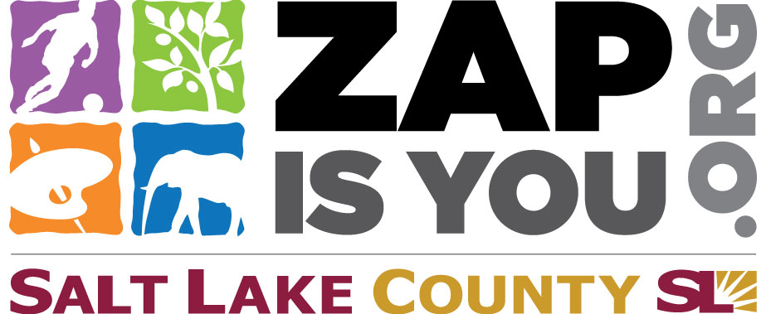
Utah Arts Festival is funded in part by the residents of Salt Lake County through the Zoo, Arts & Parks (ZAP) Program
Learn more at
www. ZAP IS You.org

