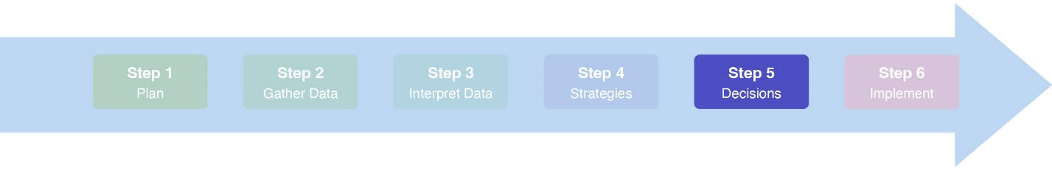
Coalitions Lite Meeting #5: Finalize Decisions| Facilitator guide

Time: 1 hour

Objectives
- Set expectations for the meeting
- Review workgroup’s progress on Coalitions Lite
- Finalize the strategy selection
- Review the Strategic Plan Template
- Set a process for drafting the Strategic Plan
- Wrap up and next steps

Materials
- Step 5 Standards
- Meeting #5 Facilitator Guide (this guide)
- Meeting #5 Power Point Presentation
- Meeting #5 Meeting Minutes Template
- Meeting #5 Participant Agenda
- “Strategies” flip chart sheets from Meeting #4
- Selecting Strategies to Create Change Handout (for reference during the meeting if needed)
- Voting Techniques information sheet
- Strategic Plan template

Facilitator Preparation
☐ Review Coalitions Lite Step 5 Power Point, including the notes sections
☐ Review the Meeting #5 Facilitator Guide (this guide)
☐ Decide on a brief team building activity or quick check-in
☐ Make any adjustments to the meeting based on Meeting #4 check-out feedback
☐ Briefly review the Strategy Overview Tool updated in Meeting #4
☐ Briefly review the Strategic Plan Template
☐ Make copies of the Strategic Plan Template

Agenda (Facilitator Version)

Welcome, Introductions, and Overview (Slides 1-4) (10 min)
  - If necessary, conduct introductions. Identify your role as facilitator.
  - Conduct a brief team building “check in.”
  - Identify the notetaker(s) and timekeeper.
  - Review the process for taking and sharing notes and other documents.
  - Review the objectives for the meeting.

Review Progress on Coalitions Lite (Slides 5-8) (5 min)
  - Review where the workgroup is in the process.
  - Summarize the outcome of Meeting #4.
  - Review progress for any uncompleted action steps from previous meetings.

Finalize our Strategy Selection (Slides 9-11) (15 min)
  - Review and address any feedback from stakeholders on the strategy list.
  - Vote with Fist to Five on the final list.

Create a Process for Drafting the Strategic Plan (Slides 12-14) (20 min)
  - Review the Strategic Plan template.
  - Assign each section to a group member. The actual drafting of the plan will be done by various group members between Meetings #5 and #6.
  - Assign at least two members of the workgroup to review the whole draft before submitting it to the larger coalition and other key stakeholders.
  - Consider how and when the larger coalition or other stakeholders will receive the draft and how requested revisions will be addressed. This should happen prior to Meeting #6 when the full coalition will officially approve the plan. The bulk of Meeting #6 should be used for outlining the activities and steps to implement the Strategic Plan.

Wrap up and Next steps (Slides 15-19) (10 min)
  - Review assignments.
  - If not scheduled, schedule Meeting #6 (the final meeting!). Meeting #6 includes the larger coalition and other key stakeholders and should be scheduled with enough time for stakeholder review of the plan and for the workgroup to finalize revisions.
  - Lead a meeting check-out.
  - Celebrate your progress and wrap-up!

